A REPORT ON MONGO DB

INTRODUCTION

Welcome to the MongoDB 4.2 Manual! MongoDB is a document database designed for ease of development and scaling. The Manual introduces key concepts in MongoDB, presents the query language, and provides operational and administrative considerations and procedures as well as a comprehensive reference section.

MongoDB offers both a *Community* and an *Enterprise* version of the database:

* MongoDB Community is the [source available and free to use](https://github.com/mongodb/mongo/) edition of MongoDB.
* MongoDB Enterprise is available as part of the MongoDB Enterprise Advanced subscription and includes comprehensive support for your MongoDB deployment. MongoDB Enterprise also adds enterprise-focused features such as LDAP and Kerberos support, on-disk encryption, and auditing.

How to Download Mongodb

**Step 1 — Download the MongoDB MSI Installer Package**

Head over [here](https://www.mongodb.com/download-center/community) and download the current version of MongoDB. Make sure you **select MSI**as the package you want to download.

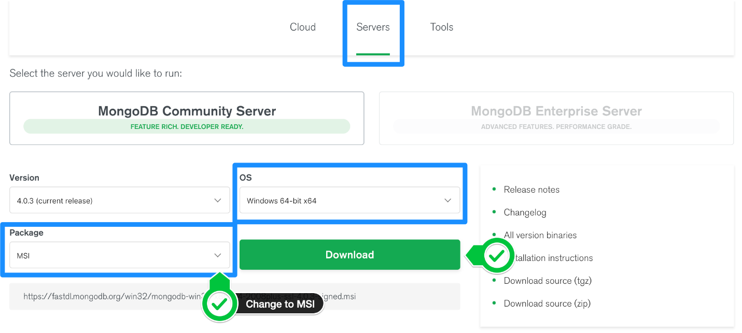

**Step 2 — Install MongoDB with the Installation Wizard**

A. Make sure you are logged in as a user with Admin privileges. Then navigate to your downloads folder and double click on the .msi package you just downloaded. This will launch the installation wizard.

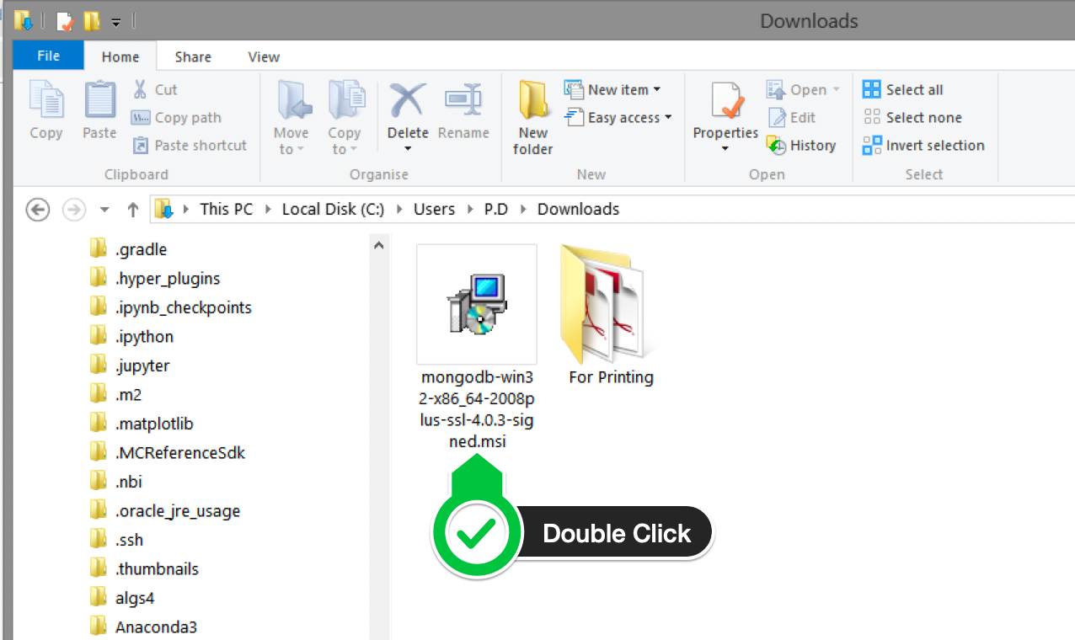

B. Click Next to start installation.

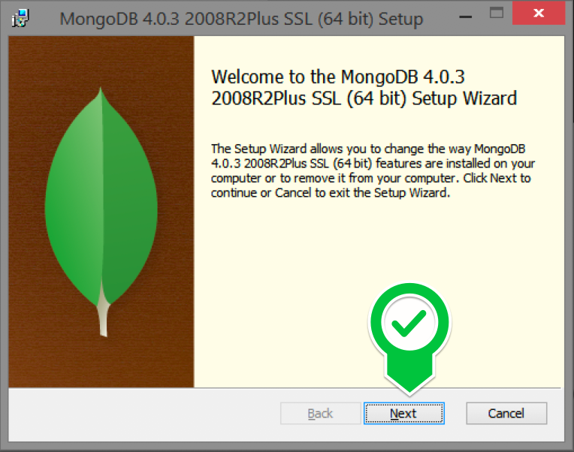

C. Accept the licence agreement then click Next

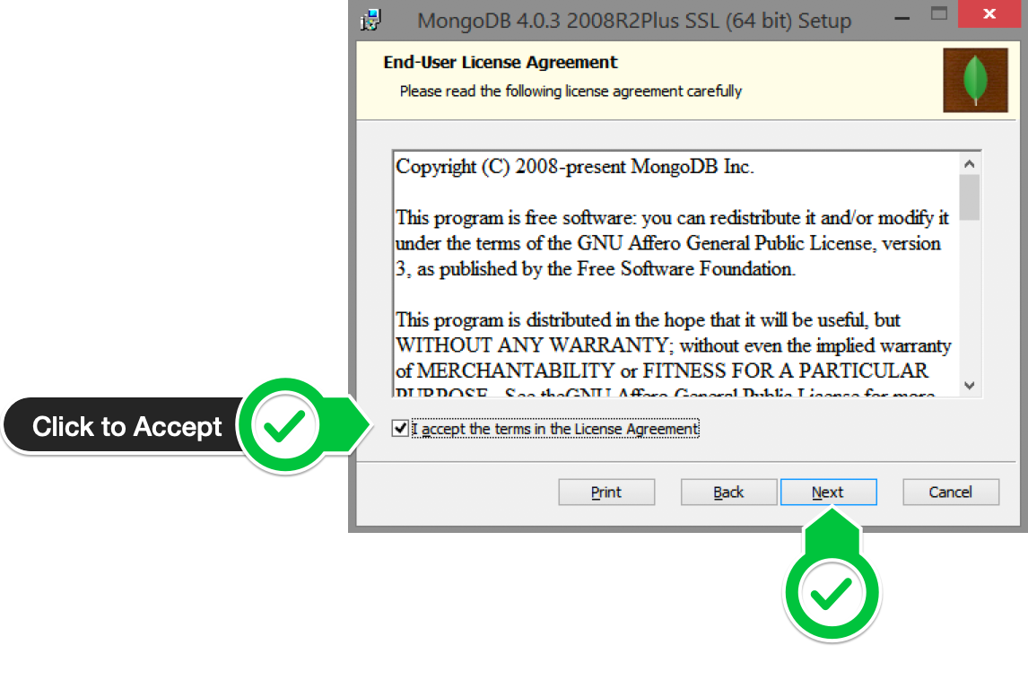

D. Select the Complete setup.

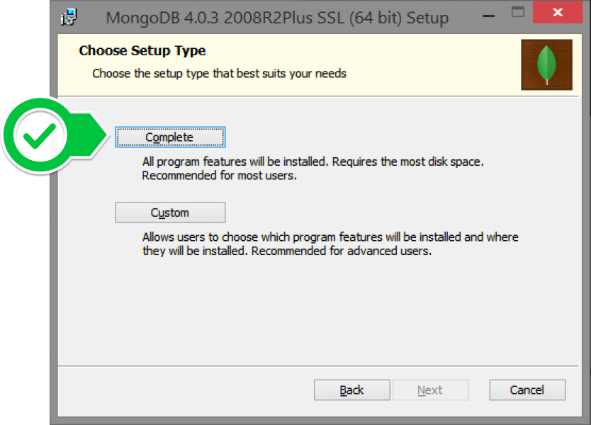

E. Select “Run service as Network Service user” and make a note of the data directory, we’ll need this later.

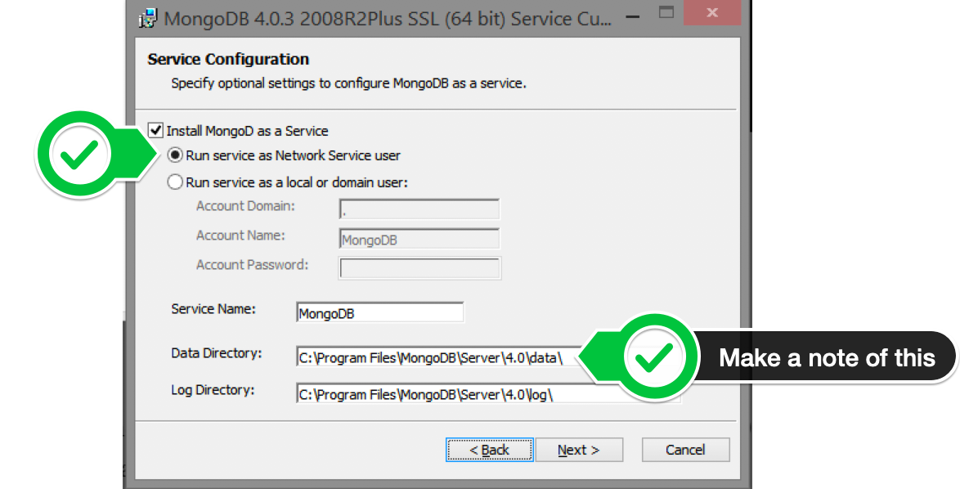

F. We won’t need Mongo Compass, so deselect it and click Next.

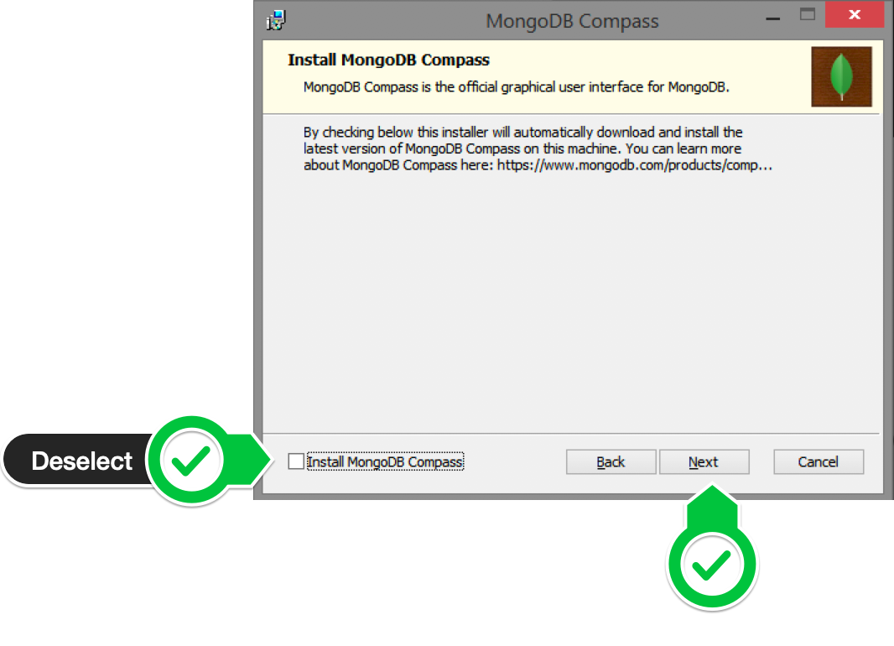

G. Click Install to begin installation.

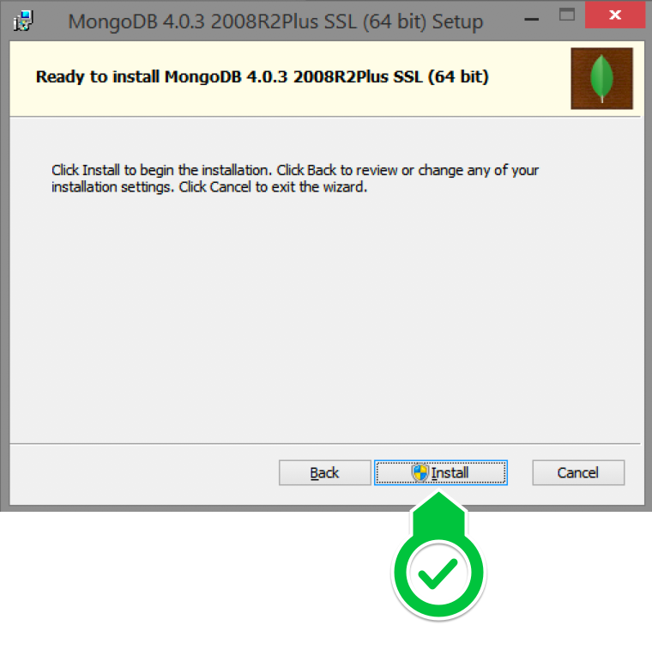

F. Hit Finish to complete installation.

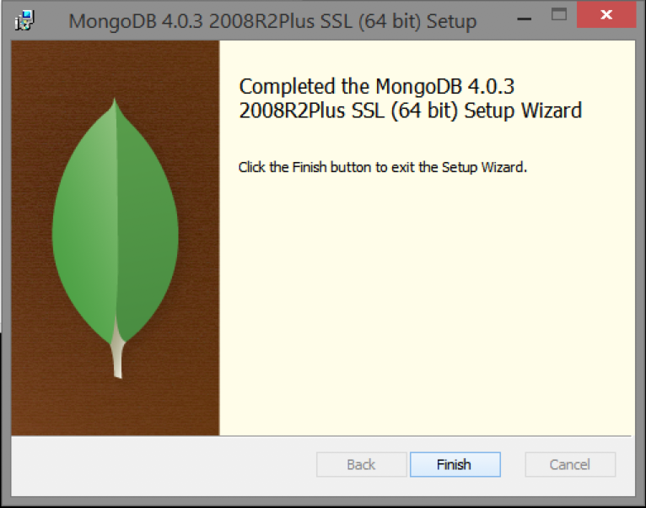

# Step 3— Create the Data Folders to Store our Databases

1. Navigate to the **C Drive** on your computer using Explorer and create a new folder called **data** here.

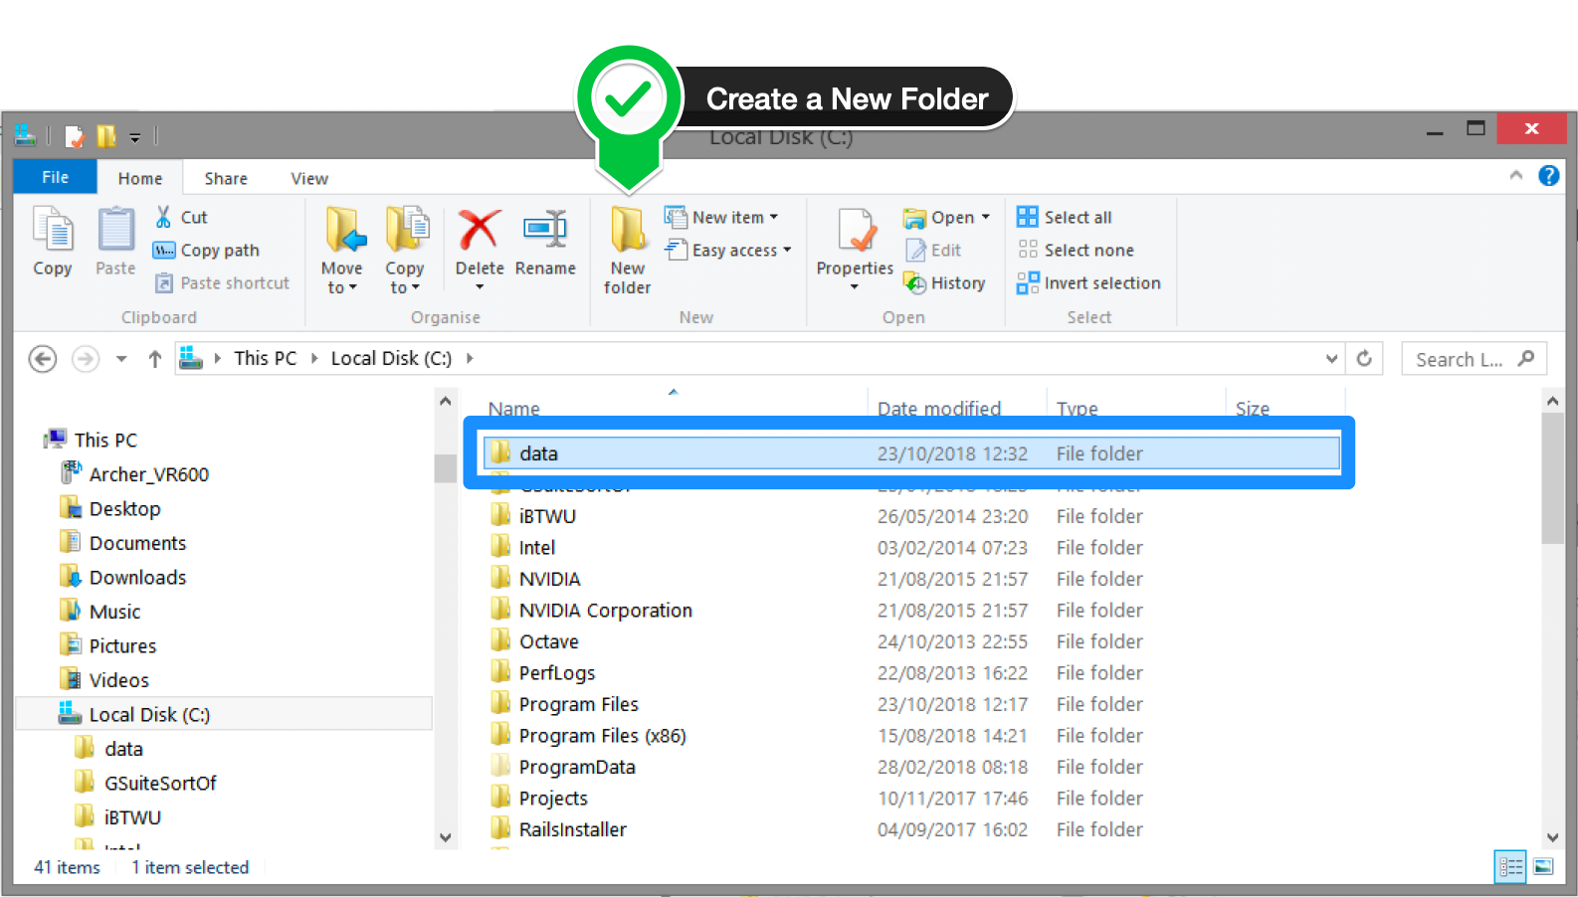

1. Inside the **data** folder you just created, create another folder called **db**.

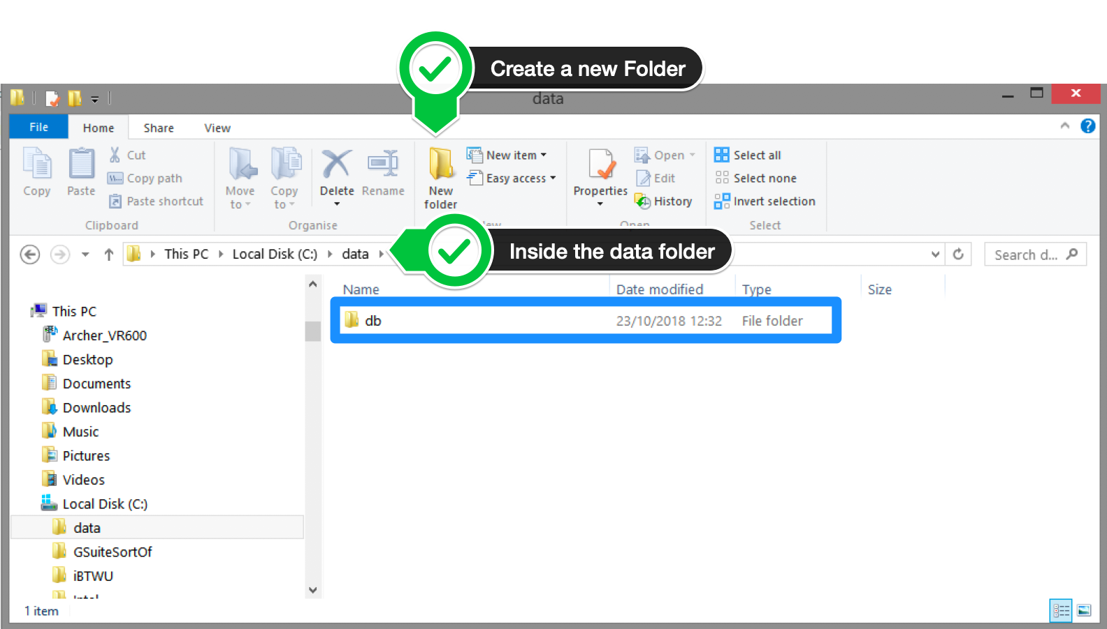

**Step 4 — Setup Alias Shortcuts for Mongo and Mongod**

Once installation is complete, we’ll need to set up MongoDB on the local system.

A. Open up your Hyper terminal running Git Bash.

B. Change directory to your home directory with the following command:

cd ~

C. Here, we’re going to create a file called .bash_profile using the following command:

touch .bash_profile

D. Open the newly created .bash_profile with vim using the following command:

vim .bash_profile

E. In vim, hit the **I** key on the keyboard to enter insert mode.

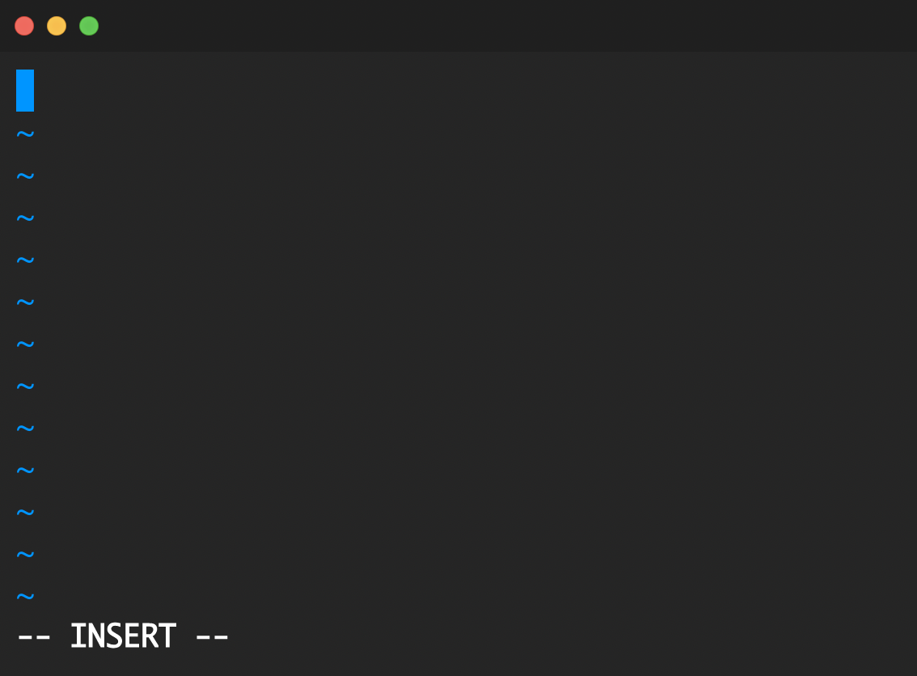

F. In your explorer go to C → Program Files → MongoDB → Server

Now you should see the version of your MongoDB.

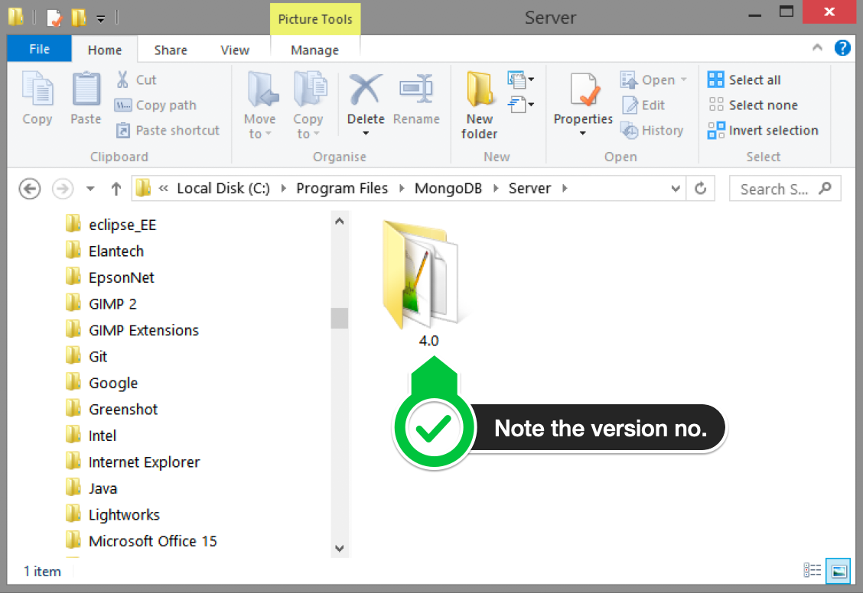

G. Paste in the following code into vim, make sure your replace the 4.0 with your version that you see in explorer

alias mongod="/c/Program\ files/MongoDB/Server/4.0/bin/mongod.exe"  
alias mongo="/c/Program\ Files/MongoDB/Server/4.0/bin/mongo.exe"

F. Hit the Escape key on your keyboard to exit the insert mode. Then type

:wq!

to save and exit Vim.

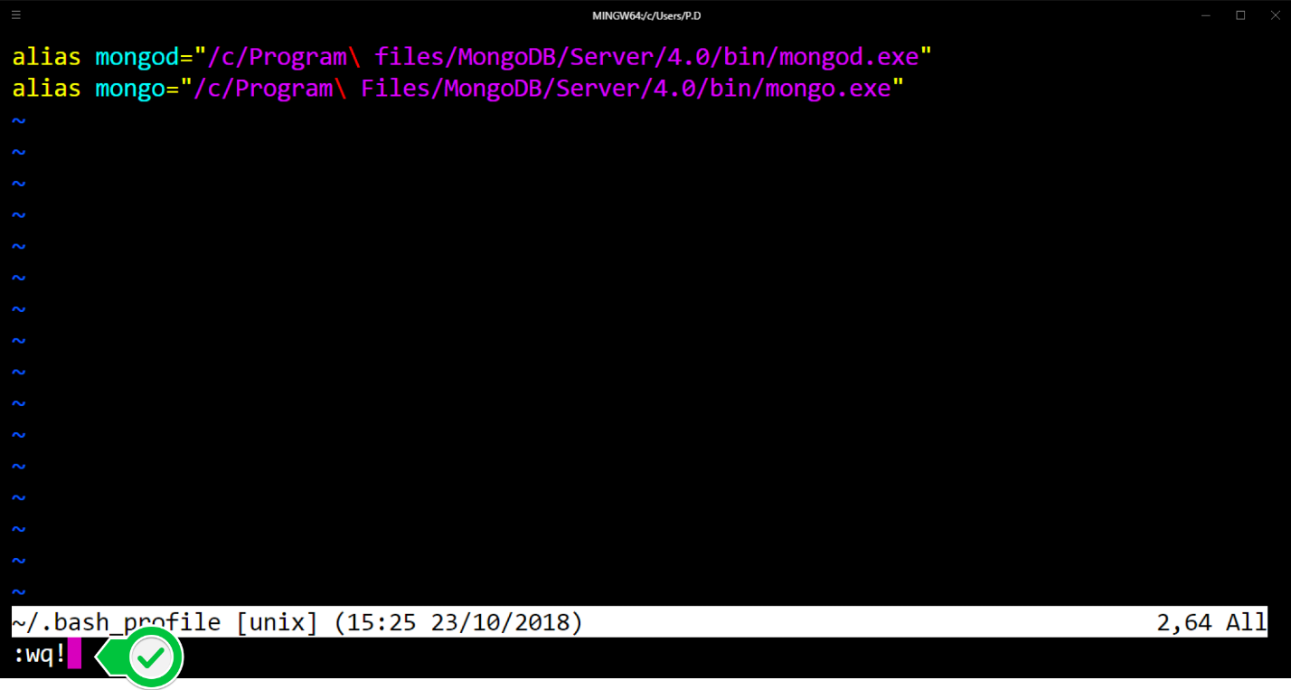

# Step 5 — Verify That Setup was Successful

A. Close down the current Hyper terminal and quit the application.

B. Re-launch Hyper.

C. Type the following commands into the Hyper terminal:

mongo --version

Once you’ve hit enter, you should see something like this:

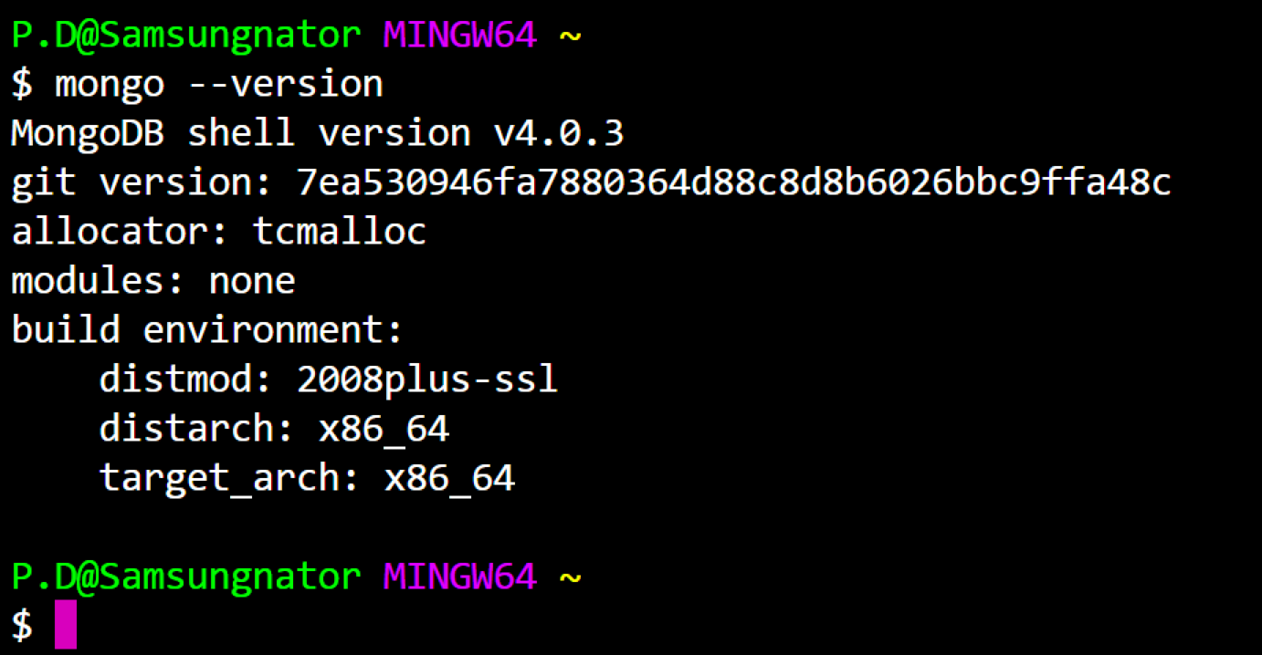

This means that you have successfully installed and setup MongoDB on your local system!

If you see something that looks like bash mongo command not found, then make sure you check back at all the steps above and follow it step-by-step making sure there are no typos and you haven’t missed any of the steps.

## Key characteristics of MongoDB

MongoDB is a very JavaScript-friendly database. It exposes a JavaScript API we can use to create databases and collections of objects (called documents).

It’s schemaless, which means you don’t need to pre-define a structure for the data before storing it.

In MongoDB you can store any object without having to worry about the particular fields that compose this object and how to store them. You tell MongoDB to store that object.

Data is stored in a format similar to JSON, but enhanced to allow storing more than just basic data types